Program :

*#include* <iostream>

*#include* <cstring>

*#include* <string>

*#include* <stack>

*using* *namespace* std;

*struct* Node

{

*int* data;

*struct* Node *\**next;

} *\**top *=* NULL;

*void* push(*int*);

*void* pop();

*void* display();

*void* postfix();

*void* push(*int* *value*)

{

*struct* Node *\**newNode;

    newNode *=* (*struct* Node *\**)malloc(*sizeof*(struct Node));

    newNode->data *=* value;

*if* (top *==* NULL)

        newNode->next *=* NULL;

*else*

        newNode->next *=* top;

    top *=* newNode;

    cout *<<* ("\nInsertion is Success!!!\n");

}

*void* pop()

{

*if* (top *==* NULL)

        cout *<<* ("\nStack is Empty!!!");

*else*

    {

*struct* Node *\**temp *=* top;

        cout *<<* ("\nDeleted element: %d", temp->data);

        top *=* temp->next;

        free(temp);

    }

}

*void* display()

{

*if* (top *==* NULL)

        cout *<<* ("\nStack is Empty!!!\n");

*else*

    {

*struct* Node *\**temp *=* top;

*while* (temp->next *!=* NULL)

        {

            cout *<<* ("\t", temp->data) *<<* ", ";

            temp *=* temp->next;

        }

        cout *<<* ("\t", temp->data) *<<* ", ";

    }

}

*struct* Stack

{

*int* top;

*unsigned* capacity;

*int* *\**array;

};

*// Stack Operations*

*struct* Stack *\**createStack(*unsigned* *capacity*)

{

*struct* Stack *\**stack *=* (*struct* Stack *\**)malloc(*sizeof*(struct Stack));

*if* (*!*stack)

*return* NULL;

    stack->top *=* *-*1;

    stack->capacity *=* capacity;

    stack->array *=* (*int* *\**)malloc(stack->capacity *\** *sizeof*(*int*));

*if* (*!*stack->array)

*return* NULL;

*return* stack;

}

*int* isEmpty(*struct* Stack *\*stack*)

{

*return* stack->top *==* *-*1;

}

*char* peek(*struct* Stack *\*stack*)

{

*return* stack->array[stack->top];

}

*char* pop(*struct* Stack *\*stack*)

{

*if* (*!*isEmpty(stack))

*return* stack->array[stack->top*--*];

*return* '$';

}

*void* push(*struct* Stack *\*stack*, *char* *op*)

{

    stack->array[*++*stack->top] *=* op;

}

*int* evaluatePostfix(*char* *\*exp*)

{

*struct* Stack *\**stack *=* createStack(strlen(exp));

*int* i;

*if* (*!*stack)

*return* *-*1;

*for* (i *=* 0; exp[i]; *++*i)

    {

*if* (isdigit(exp[i]))

            push(stack, exp[i] *-* '0');

*else*

        {

*int* val1 *=* pop(stack);

*int* val2 *=* pop(stack);

*switch* (exp[i])

            {

*case* '+':

                push(stack, val2 *+* val1);

*break*;

*case* '-':

                push(stack, val2 *-* val1);

*break*;

*case* '\*':

                push(stack, val2 *\** val1);

*break*;

*case* '/':

                push(stack, val2 */* val1);

*break*;

            }

        }

    }

*return* pop(stack);

}

*int* main()

{

*int* choice, value;

    cout *<<* ("\n\*\*\*\*\*\*\*\*\* MENU \*\*\*\*\*\*\*\*\*\*\n");

    cout *<<* "\* 1. Push in stack      \*" *<<* endl;

    cout *<<* "\* 2. Pop from stack     \*" *<<* endl;

    cout *<<* "\* 3. Display stack      \*" *<<* endl;

    cout *<<* "\* 4. Postfix Evaluation \*" *<<* endl;

    cout *<<* "\* 5. Exit               \*" *<<* endl;

    cout *<<* "\*\*\*\*\*\*\*\*\*\*\*\*\*\*\*\*\*\*\*\*\*\*\*\*\*" *<<* endl;

*do*

    {

        cout *<<* ("\nEnter your choice: ");

        scanf("%d", *&*choice);

*switch* (choice)

        {

*case* 1:

            cout *<<* ("Enter the value to be insert: \n");

            scanf("%d", *&*value);

            push(value);

*break*;

*case* 2:

            pop();

*break*;

*case* 3:

            display();

*break*;

*case* 4:

        {

*char* exp[] *=* "10 20 \* 30 60 10 / - +";

            cout *<<* "Postfix Evaluation: " *<<* evaluatePostfix(exp)*<<*"\n";

*return* 0;

        }

*case* 5:

            exit(0);

*break*;

*default*:

            cout *<<* ("\nWrong selection!!! Please try again!!!\n");

        }

    } *while* (choice *!=* 4);

*return* 0;

}

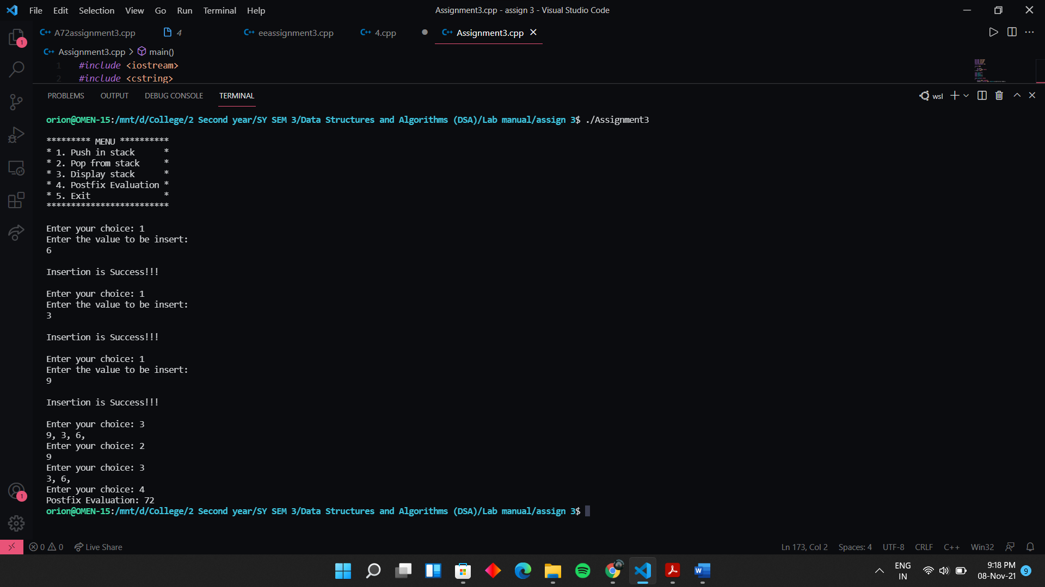Output :